One Page Abstract Template for the ICON Workshop

**Author 1**1**, Author 2**2**, Author 3**1

*1. Affiliation 1*

*2. Affiliation 2*

E-mail: your institutional email

**Oral/Poster contribution**

This is a sample one-page abstract for submissions to the Nonlinear Cell Photonics Workshop (ICON-W), which will take place between April 2nd and 4th, 2025 in Nice, France. Please ***select oral*** **or** ***poster*** contribution according to your submission.

The abstract must be submitted in **PDF format exclusively** and must **not exceed** the **one page** limit. Please **do not change** the margins or the header and footer. Use only 10-point “Times New Roman” for text fonts. The figures can be provided in greyscale or colors. Figure captions should be centered beneath figures and in an 8-point font. References should appear at the end of the text in the order in which they are referenced in the body of the abstract. The font should be 8-point and the references should be aligned left. A suggested format for references is given below.

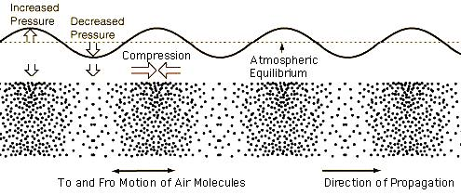

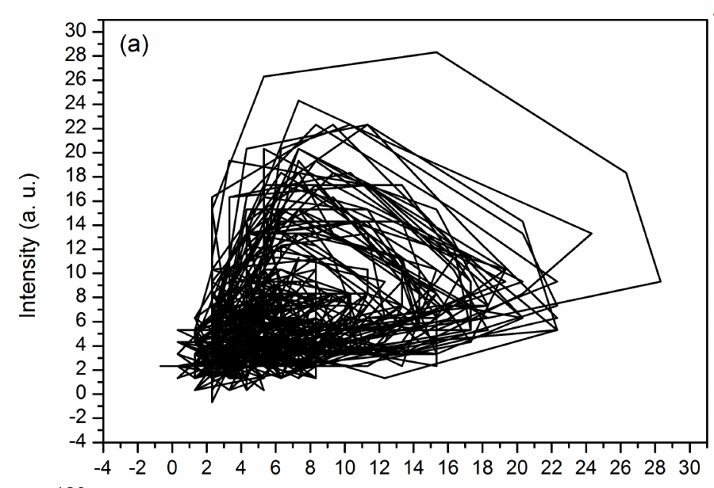**Fig. 1** Place a figure or an image here, with its own caption.

**References**

[1] D.M. **Kuchta, Chap. 16 in *VCSELs*, R. Michalzik ed. (Springer, Berlin, 2013).**

**[2] H. Soda, K. Iga, C. Kitahara, and Y. Suematsu, "GaInAs/InP surface emitting injection lasers", Jpn. J. Appl. Phys. 18, 2329 (1979).**